Revolution Robotics Challenge Kit User Manual (SA-RR-CK 2.0) Rev. 2024/08

# Table of contents

**Table of contents 1**

**Chapter 1: Introduction 2**

About Revolution Robotics 2

Purpose of the Manual 2

**Chapter 2: Safety Information 3**

General Safety Precautions 3

**Chapter 3: Product Overview 4**

Components and Features 4

**Chapter 4: Setup and Installation 5**

Unboxing 5

Central Control Unit (Robot Brain) 6

Software Installation 7

App & Kit Usage 8

**Chapter 5: Contact information 14**

Customer Support 14

# 

# 

# Chapter 1: Introduction

## About Revolution Robotics

Revolution Robotics is an innovative robotics kit, incorporating challenges, and competitions aimed at developing essential 21st-century skills. Our mission is to inspire children globally to pursue STEM education and careers. This manual provides comprehensive instructions for setting up, operating, and maintaining your robotics kit. Revolution Robotics is a STEAM Academy brand.

## Purpose of the Manual

This manual is intended to provide comprehensive instructions for safely setting up, operating, and maintaining your Revolution Robotics platform.

# 

# Chapter 2: Safety Information

## General Safety Precautions

* **Intended Use**: The Revolution Robotics Challenge Kit is designed for children aged 7 and above. Adult supervision by a school teacher or parent is required at all times.
* **Read Before Use**: Carefully read all instructions before using the kit.
* **Water and Moisture**: Keep the robotics kit away from water and moisture to avoid damage and electrical hazards.
* **Handling**: Avoid dropping the components or subjecting them to physical shock.
* **Power Supply**: The Central Control Unit (Robot Brain) can be charged via USB. The battery pack requires 6 AA batteries. Use only the specified battery type and ensure they are inserted correctly.
* **Connections**: Make sure all components are securely connected before powering on the robot.
* **Application Use**: The robot is controlled through an application available on iOS and Android devices. Ensure the app is installed and used according to the instructions provided.
* **Battery Safety**: Follow proper battery usage and disposal guidelines. Do not attempt to open or modify the batteries.

# 

# Chapter 3: Product Overview

## Components and Features

The Revolution Robotics Challenge Kit includes the following components:

* **Central Control Unit (Robot Brain)**
  + The main processing unit that controls the robot’s functions.
  + Chargeable via USB.
  + Contains 12 programmable LEDs.
* **Motors**
  + Provide movement to the robot.
  + Connect to the Central Control Unit.
* **Sensors**
  + **Ultrasonic Sensor**: Measures distance.
  + **Button Sensor**: Detects physical interactions.
  + **Color Sensor**: Detects colors.
  + **Gyroscope**: Built into the Robot Brain for orientation and movement detection.
* **Wheels and Chassis**
  + The chassis is made of several plastic components, including straight, angled, and curved beams, pins, gears, wedges, and axles.
  + Wheels attach to the motors to enable movement.
* **Connecting Cables**
  + Used to connect motors and sensors to the Central Control Unit.
* **Battery Pack**
  + Requires 6 AA batteries.
  + Powers the motors.

# Chapter 4: Setup and Installation

## Unboxing

1. Carefully unpack all items from the package. Remove plastic bags (if any) and put the parts into their trays based on the layout provided.

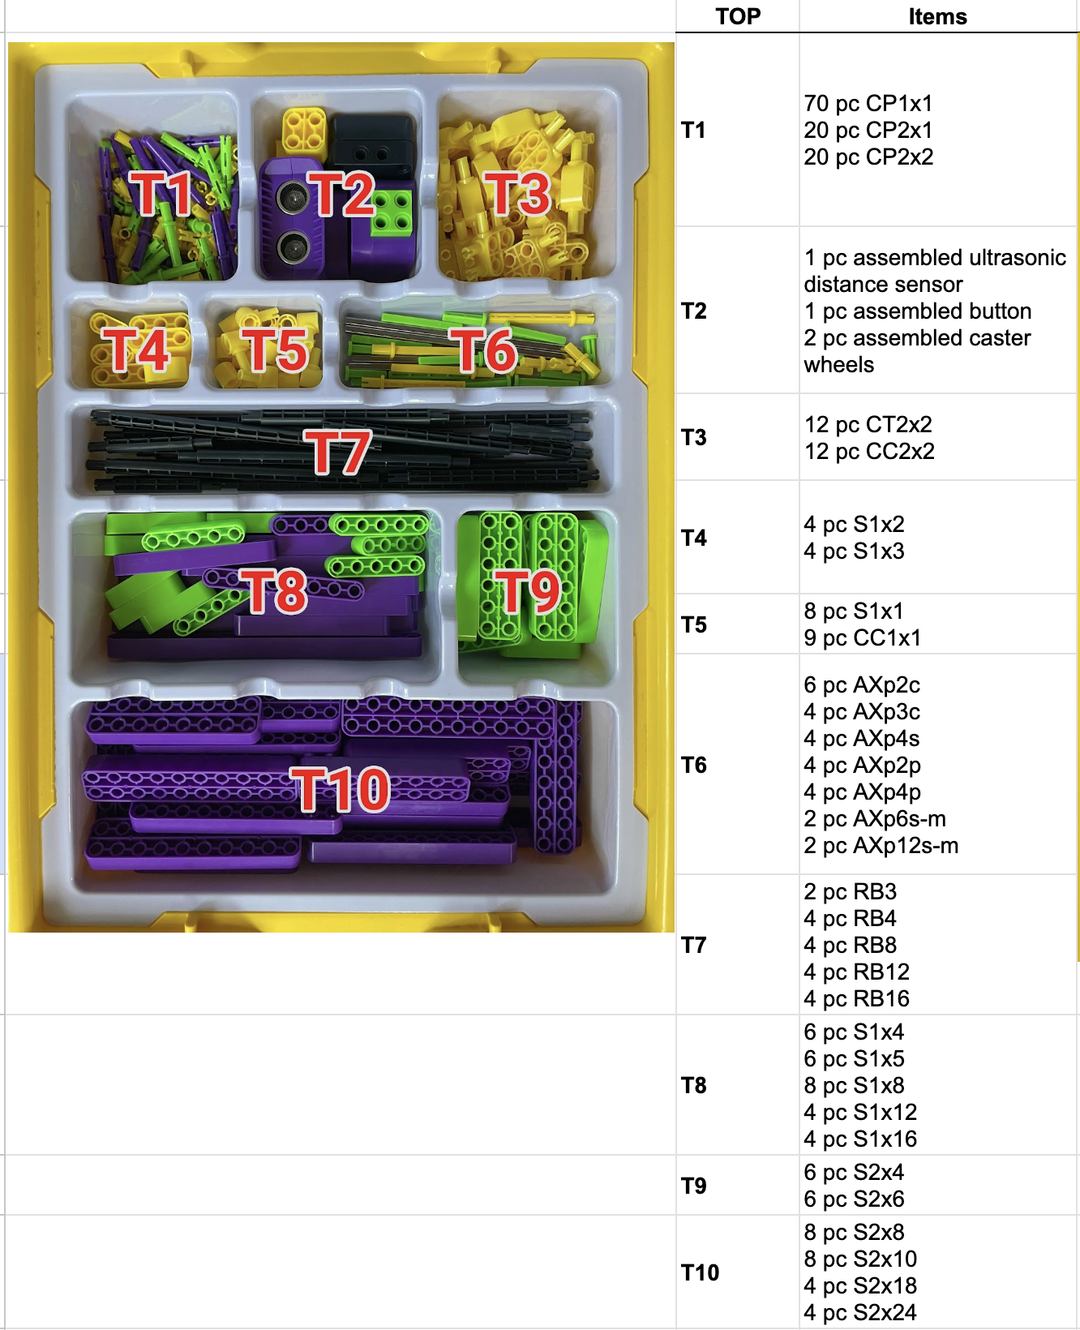

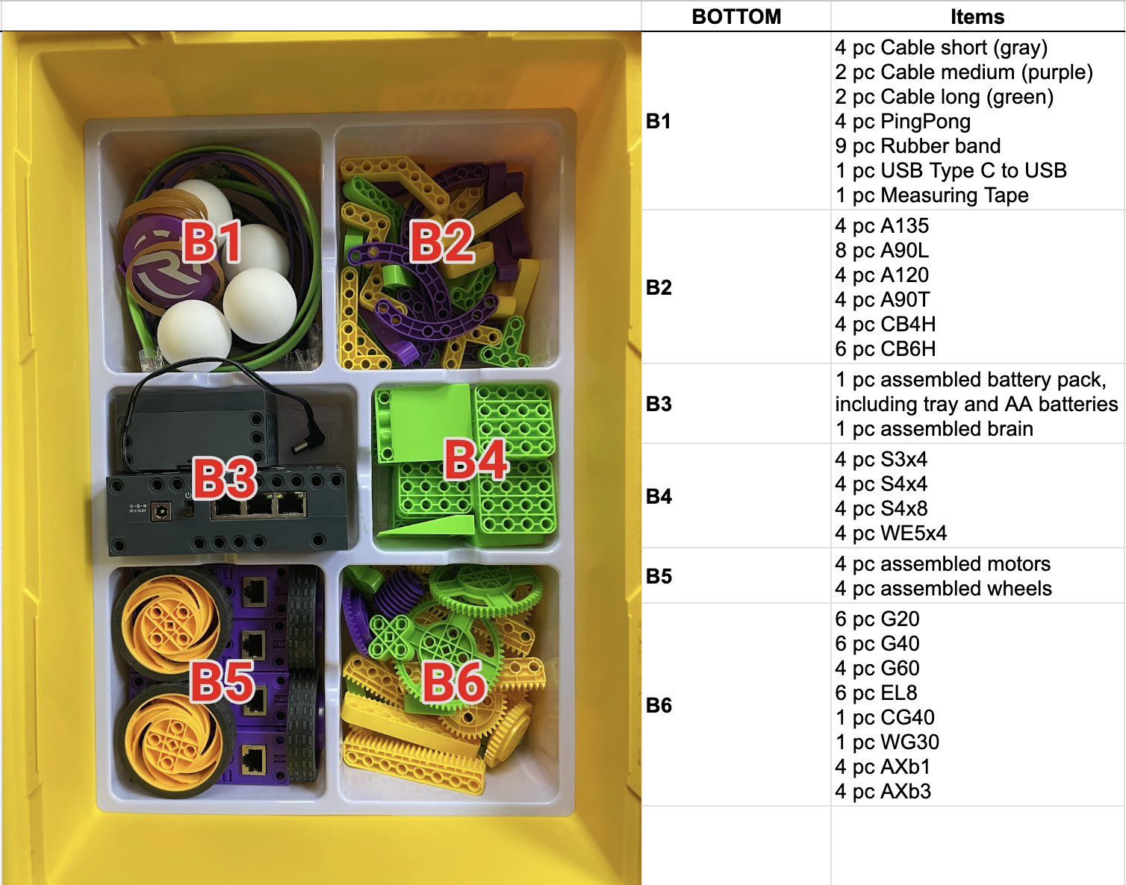

1. Check all components against the included checklist to ensure everything is present.
2. Inspect components for any visible damage.

## Central Control Unit (Robot Brain)

1. Turn ON the Robot Brain with the side switch. The yellow circle indicates the booting process
2. When the circle is complete it’ll turn to green and the robot is ready to use

| Booting sequence | Ready to use |
| --- | --- |

## Software Installation

1. **Download**: Download the **Revolution Robotics application** from the App Store (iOS) or Google Play Store (Android).
2. **Install**: Follow the on-screen instructions to install the app on your mobile or tablet device.
3. **Grant permissions**: Open the app and grant necessary permissions, such as bluetooth, camera and storage access.

## App & Kit Usage

1. **Open the application:** Open the application by tapping its icon.
2. **Select your language**: When asked, select your language via the dropdown provided.

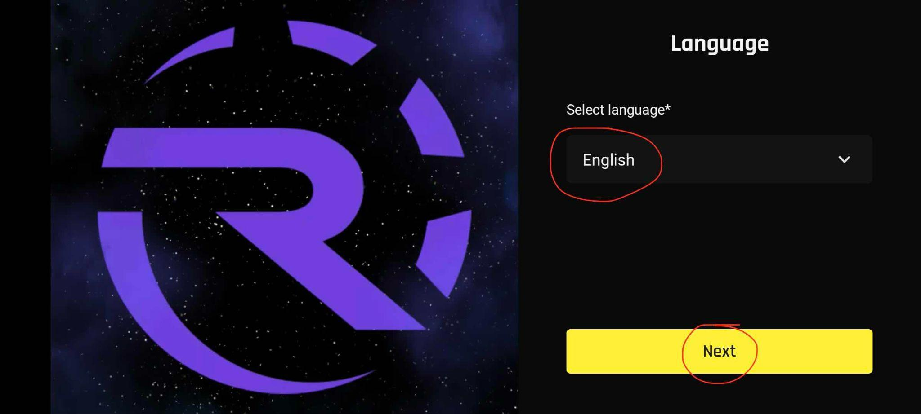

1. **Log in or Register**: Log in (Login with Code Name”), or register a new account (“I do not have a Code Name”). Complete the onboarding process as prompted by the app when registering a new account.

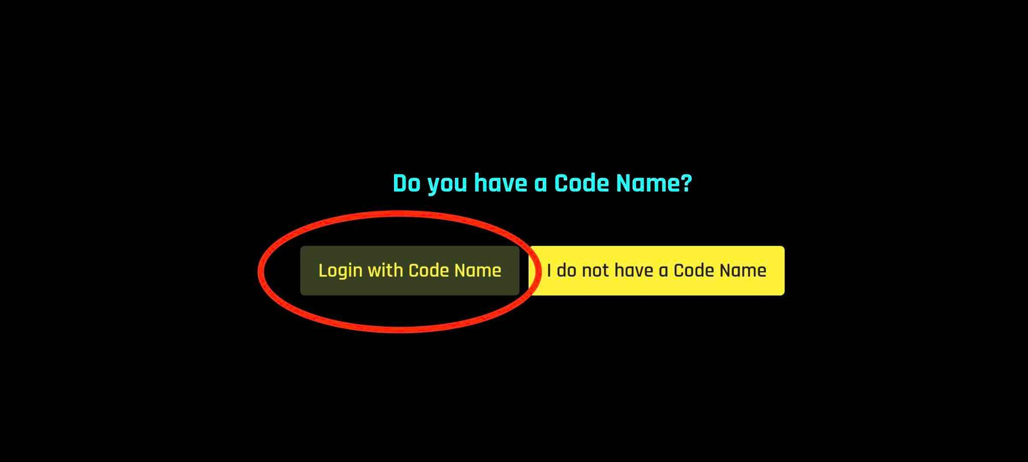

1. **Create a Robot using the Application**:
   * Go to the main screen and select Robots

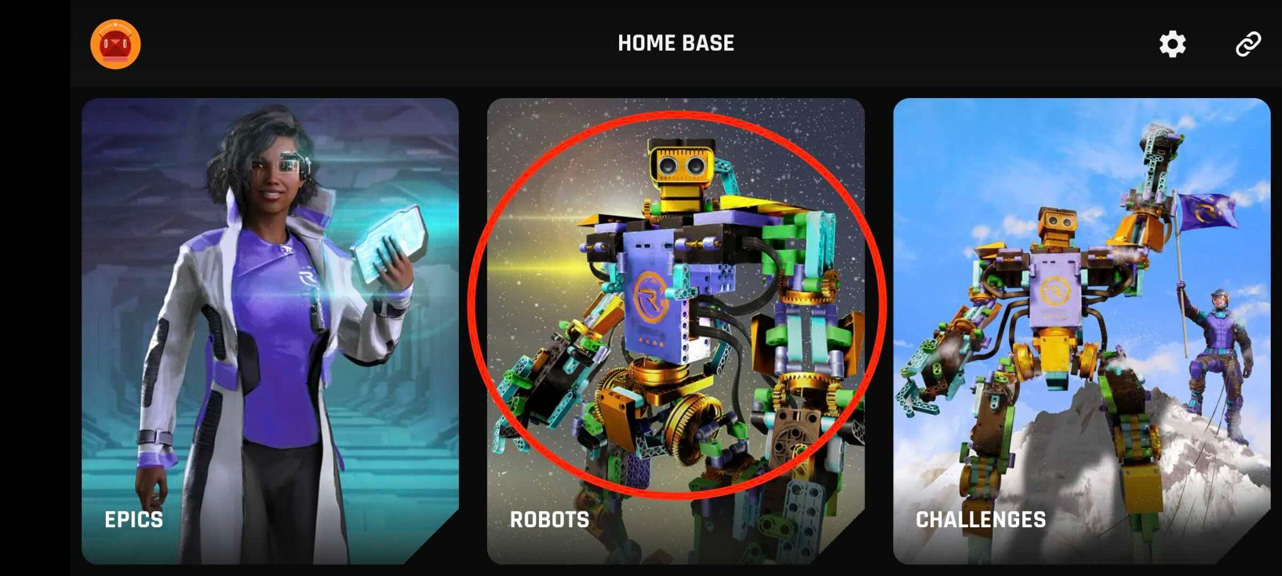

* + Select **“Building instructions”**, and pick one of the robots available.

|  |  |
| --- | --- |

* + Follow the build steps, attach kit elements, and assemble the robot

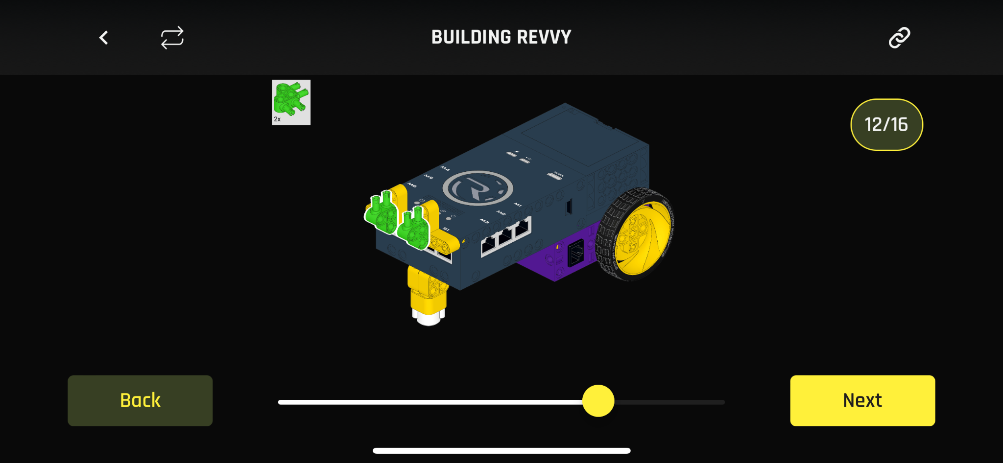

* + Use the configuration screen to match the app configuration with reality

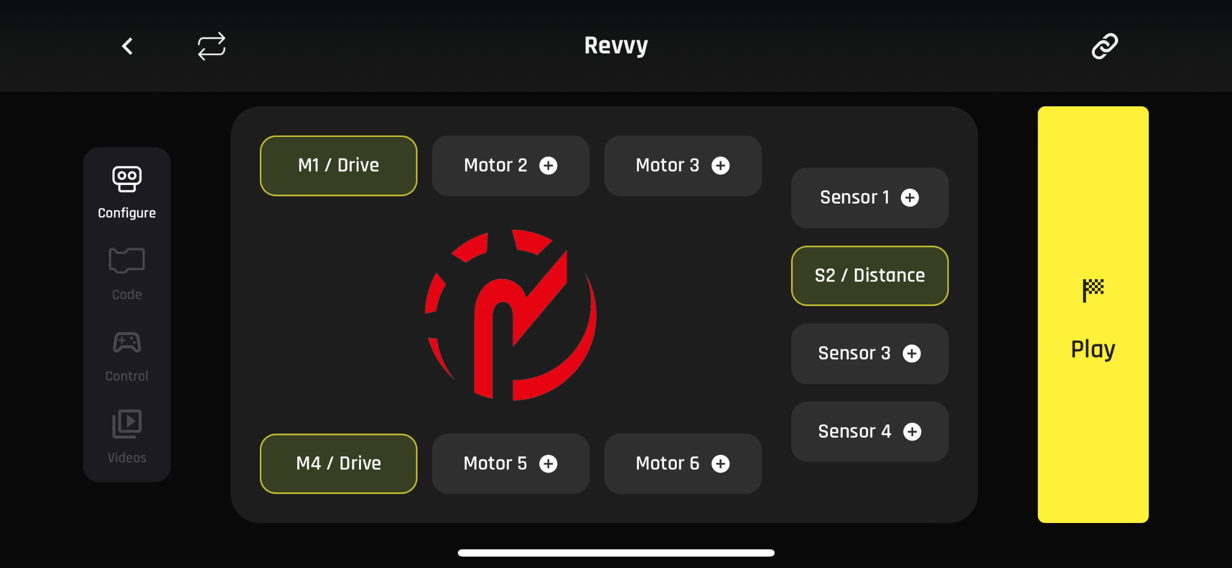

* + Ensure the Central Control Unit (Robot Brain) is powered on and LEDs are blinking green.
  + From the app, connect to the robot using the chain icon. Select the brain ID when prompted *(note: the ID is different for every brain)*

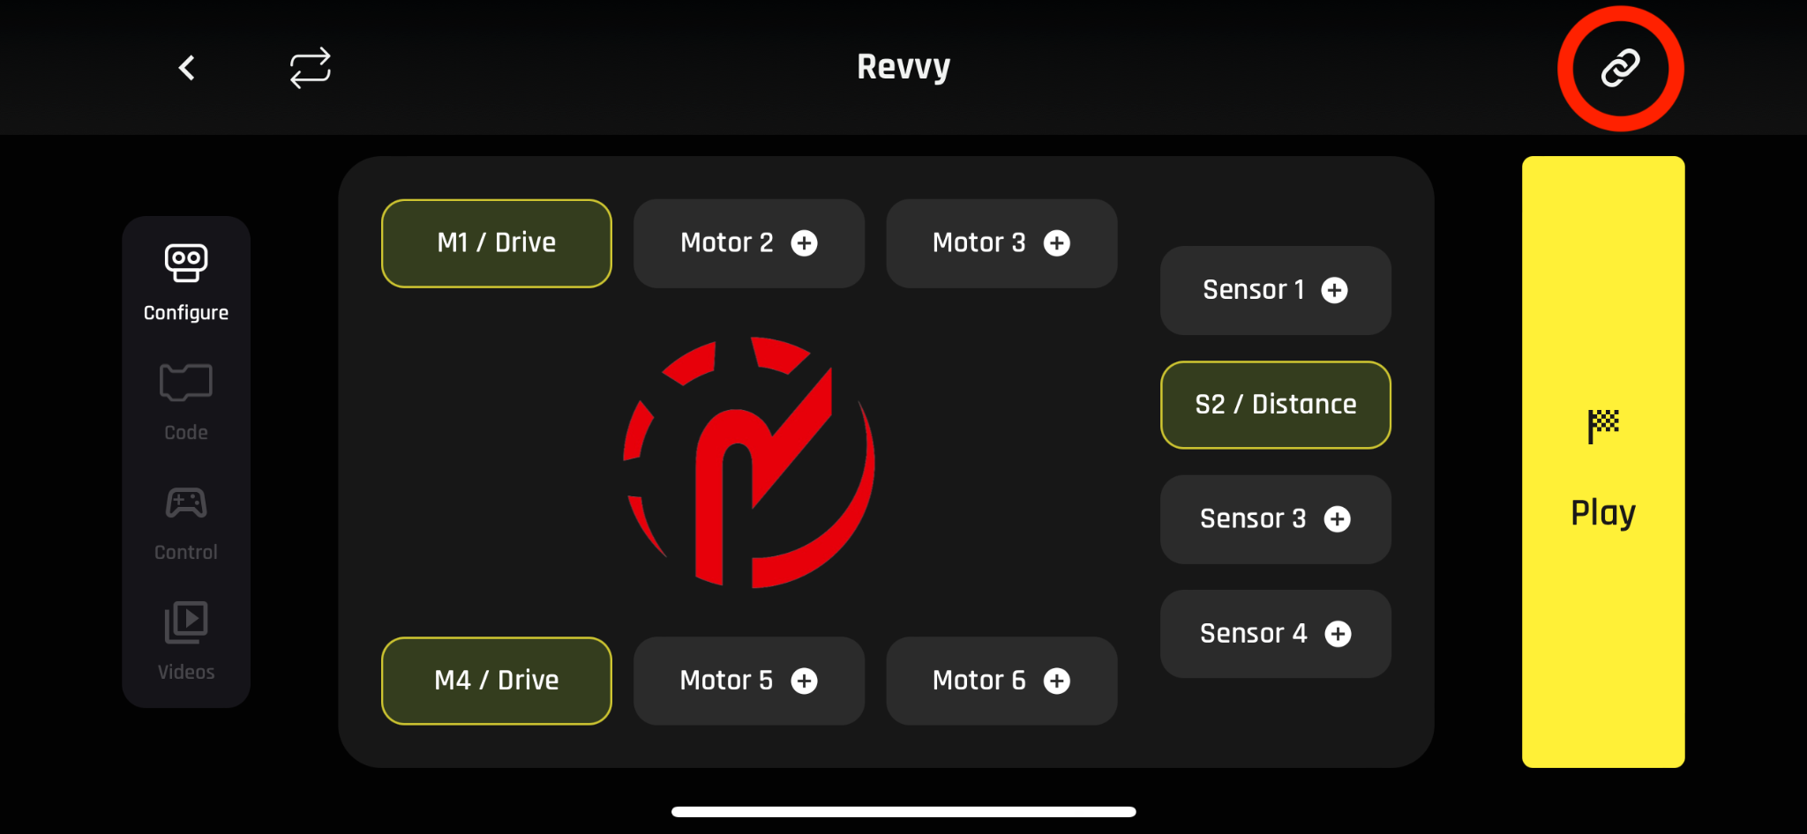

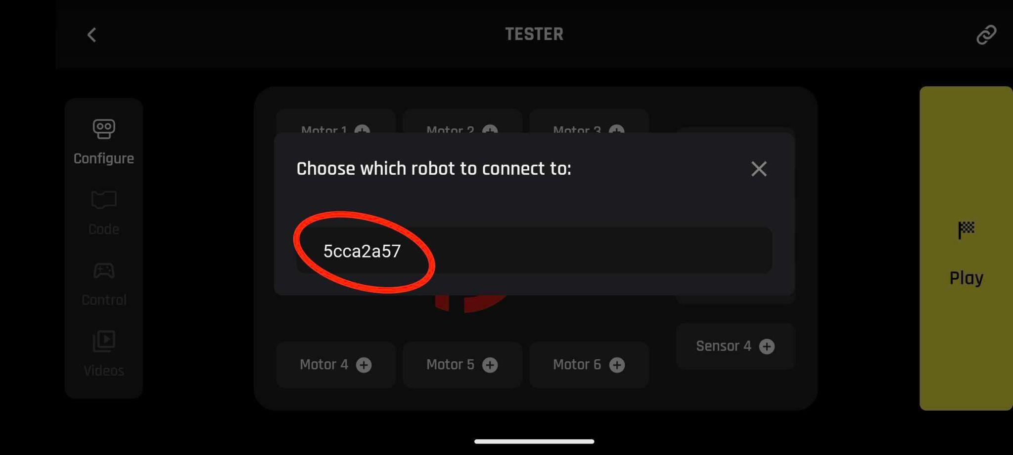

* + Wait for confirmation about the connection established. The chain icon on top right will also be coloured differently.

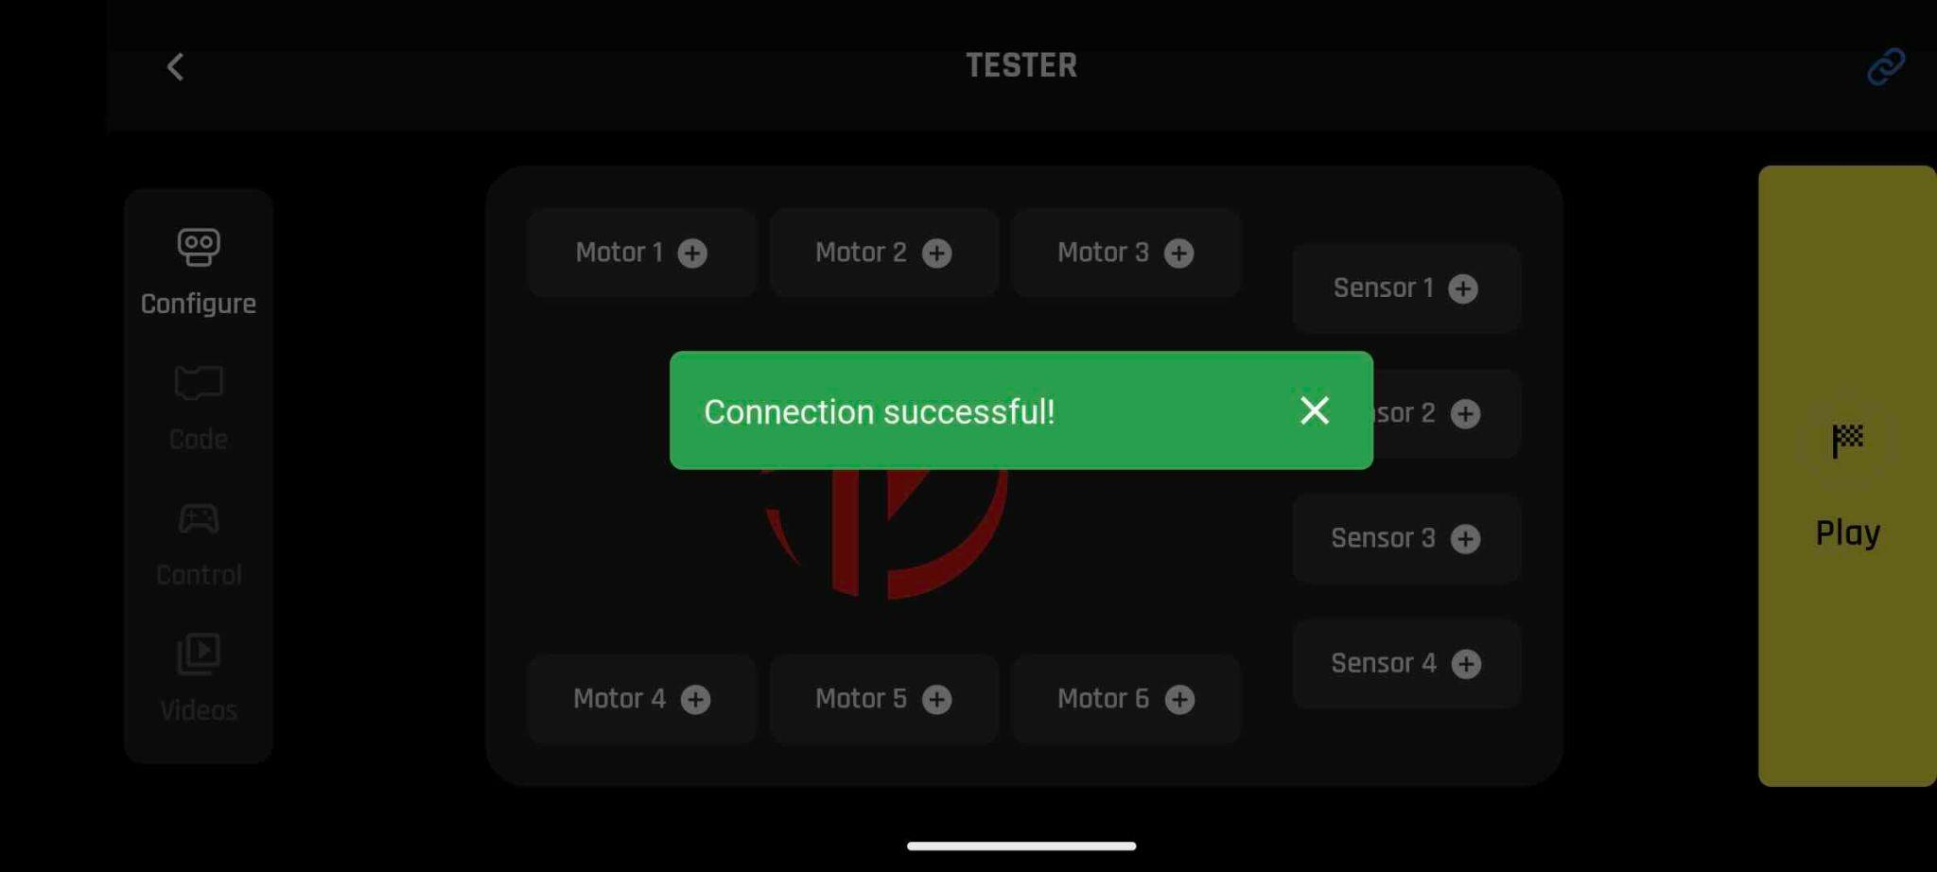

1. **Program the robot:** Go to the “**Code**” screen and add / edit / test new programs using the interface provided.

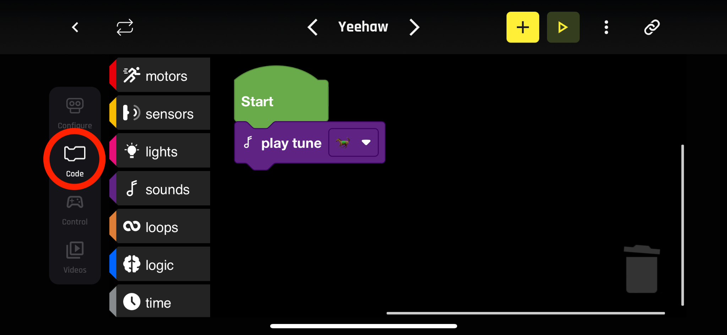

1. **Attach / remove programs & sensor values to the joystick:** Attach programs to the slots provided on the “**Control**” screen.

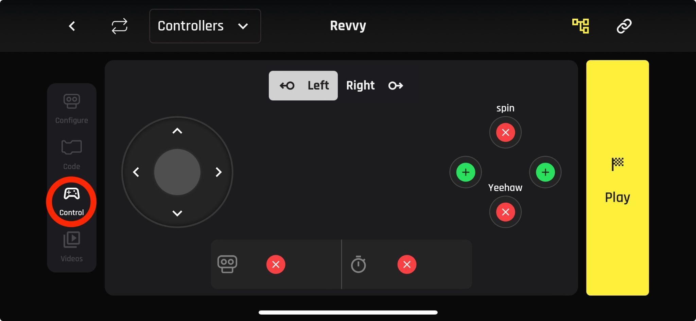

1. **Go to play mode:** Hit “Play” and control the robot using the preconfigured joystick. Navigate back and forth between screens to modify your setup and programs.

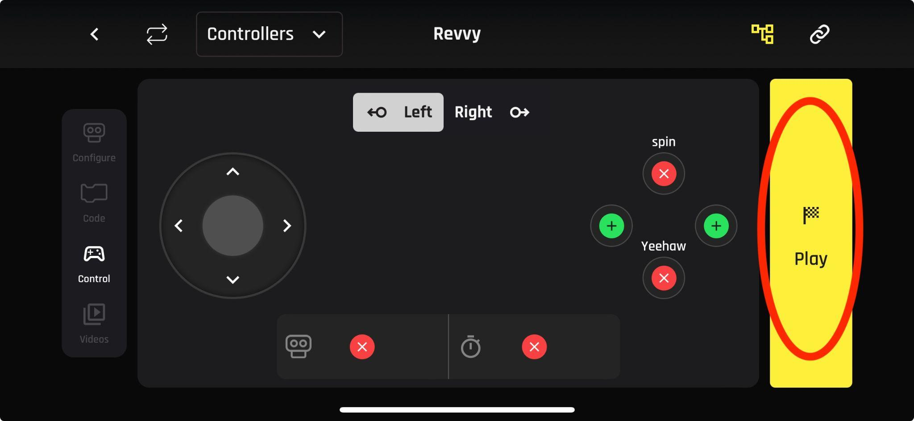

# Chapter 5: Contact information

Revolution Robotics is a brand owned and operated by STEAM Academy.

## Customer Support

For any questions, assistance, or to make a warranty claim, please contact STEAM Academy

* **Email**: info@steamacademy.pro
* **Website**: https://steamacademy.pro